Social credit system

Social credit system is a disciplinary program that involves every citizen in the nation. It is monitoring every human being through surveillance cameras by using image processing. And giving a score to everyone based on their activity in the society.

Those who will do good things which are useful for society will get a good score. For those who perform unusual activities that cause harm to the environment and society, their score will be deducted. For example, a person spits on the footpath he will be identified by the AI-based camera and his score will be deducted.

Image processing and AI plays major role in this social credit system.

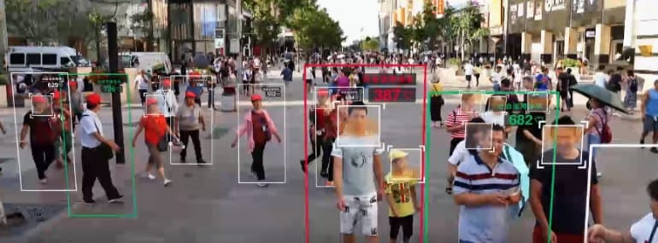

China is the first country to use this social credit system.

This is under trails in 2009 and tested in 2015 and it is about to implement national wide by 2020. This is under the control of the people’s bank of china.

China’s Social Credit System is a system that collects information about Chinese citizens from various sources, weighs the various data, and generates a ranking for each citizen.

Once implemented the system will manage the rewards, or punishments, of citizens based on their economic and personal behavior.

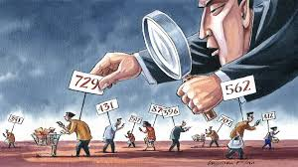

**Benefits with high credit score:**

The rewards of having a high score include easier access to loans and jobs and priority during bureaucratic paperwork.

**Consequences with low credit score:**

the immediate negative consequences for a low score, or being associated to someone with a low score, range from lower internet speeds to being denied access to certain jobs, loans and visas, flight ban, exclusion from private schools, exclusion from high prestige work, exclusion from hotels, and registration on a public blacklist.

**Advantages:**

1) controlling the people

2) Personal security

3) Economic morality

4) Execution through rewards

**Disadvantages :**

Lack of freedom is the biggest disadvantage.

By Mahesh